**Data Science vs Artificial Intelligence**

Data Science and Artificial Intelligence, are the two most important technologies in the world today. While Data Science makes use of Artificial Intelligence in its operations*,* it does not completely represent AI. In this article, we will understand the concept of Data Science vs Artificial Intelligence. Furthermore, we will discuss how researchers around the world are shaping modern Artificial Intelligence.

Data Science and  Artificial Intelligence are the most commonly used interchangeably. While Data Science may contribute to some aspects of AI, it does not reflect all of it. Data Science is the most popular field in the world today. However, real Artificial Intelligence is far from reachable. While many consider contemporary Data Science as Artificial Intelligence, it is simply not so. So, let’s explore Data Science vs Artificial Intelligence for clearing all your confusions.

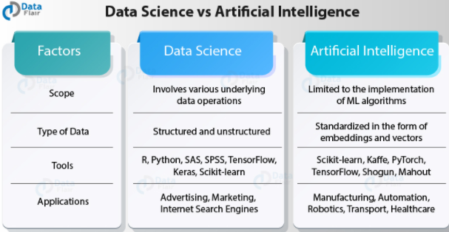

**What is data science🡪**

Data Science is the current reigning technology that has conquered industries around the world. It has brought about a fourth industrial revolution in the world today. This a result of the contribution by the massive explosion in data and the growing need of the industries to rely on data to create better products. We have become a part of a data-driven society. Data has become a dire need for industries that need data to make careful decisions.

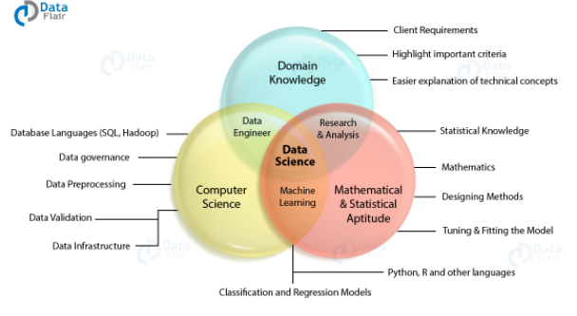

Data Science involves various underlying fields like Statistics, Mathematics, and Programming. Therefore, a data scientist is required to be proficient in them in order to understand trends and patterns in the data. This heavy requirement of skills gives Data Science a steep learning curve. Furthermore, a data scientist is required to possess.

The various steps and procedures in data science involve data extraction, manipulation, visualization and maintenance of data to forecast the occurrence of future events. A Data Scientist is should also have a sound knowledge of machine learning algorithms. These machine learning algorithms are Artificial Intelligence which we will further discuss in this article.

Industries require data scientists to help them make necessary data-driven decisions. They help the industries to assess their performance and also suggest necessary changes to boost their performance. They also help the product development team to tailor products that appeal to customers by analyzing their behavior.

**What is Artificial Intelligence🡪**

Artificial Intelligence is the intelligence that is possessed by the machines. It is modeled after the natural intelligence that is possessed by animals and humans. Artificial Intelligence makes the use of algorithms to perform autonomous actions. These autonomous actions are similar to the ones performed in the past which were successful.

Many traditional Artificial Intelligence algorithms were explicitly provided goals, as was in the case of path finding algorithms like A*. However, contemporary AI Algorithms like deep learning understand the patterns and find the goal embedded in the data. Artificial Intelligence also makes use of several software engineering principles for developing solutions to existing problems.

Recently, many major technology giants like Google, Amazon, and Facebook are leveraging Artificial Intelligence to develop autonomous systems. The most famous example is that of Google’s AlphaGo. This autonomous Go playing system defeated the Ke Jie, a world’s number 1 professional AlphaGo player. The AlphaGo made use of the artificial natural networks that are modeled after the human neurons that learn information over time and execute actions.

## How is Artificial Intelligence Different from Data Science?

Let’s start exploring Data Science vs Artificial Intelligence through the below points –

#### **1. Constraints of Contemporary AI**

Artificial Intelligence and Data Science can use interchangeably. But there are certain differences between the two fields. The contemporary AI used in the world today is the ‘Artificial Narrow Intelligence’. Under this form of intelligence*,*computer systems do not have full autonomy and consciousness like human beings. Rather, they are only able to perform tasks that they are trained for*.* **For example**, an AlphaGo may be able to defeat the world’s No. 1 Go champion, but he will not know that it is playing the game of AlphaGo. That is, it does not have a conscious mind.

[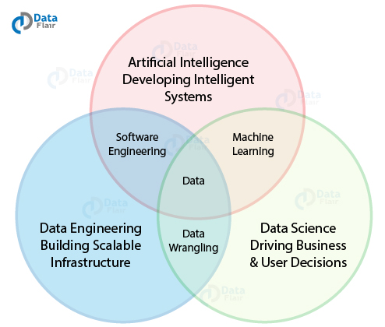](https://d2h0cx97tjks2p.cloudfront.net/blogs/wp-content/uploads/sites/2/2019/04/Data-science-and-Artificial-Intelligence-relation.jpg)

#### **2. Data Science is a Comprehensive Procedure**

Data Science is the analysis and study of data. A Data Scientist is responsible for making decisions that benefit companies*.* Moreover, the role of data scientist varies with the industry. In the everyday roles and responsibilities of a data scientist, the main requirement is to preprocess data, that is, performing data cleaning and transformation. He then analyzes the patterns in the data and uses visualization techniques to draw graphs that underline the analytical procedures. Then he develops prediction models that find the likelihood of the occurrence of future events.

#### **3. Artificial Intelligence is a tool for Data Scientist**

For a Data Scientist, Artificial Intelligence is a tool or a procedure. This procedure sits at top of the other methodologies, used for analyzing the data. This is best analogized through Maslow’s Hierarchy where each component of the pyramid represents a data operation that is performed by a Data Scientist.

[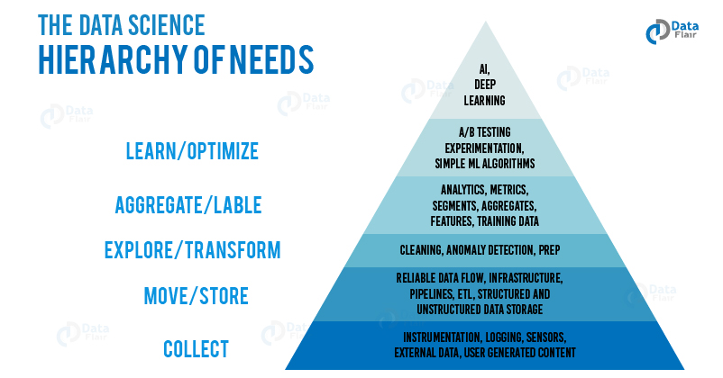](https://d2h0cx97tjks2p.cloudfront.net/blogs/wp-content/uploads/sites/2/2019/04/The-Data-Science-hierarchy-of-needs-01.jpg)

Various roles and requirements of the company also highlight the key differences between Artificial Intelligence and Data Science. **For example**, several companies require pure AI positions like Deep Learning Scientist, Machine Learning Engineer, NLP Scientist etc. These requirements are mostly for developing products that live and breathe in AI. Many of these roles require Data science tools like R and Python for performing various data operations but also require additional computer science expertise.

A Data Scientist, on the other hand, helps the company and businesses to make careful **data-driven decisions.** A Data Scientist is responsible for extracting data using SQL and NoSQL queries, cleaning various anomalies in the data, analyzing the patterns in data and applying predictive models to generate future insights. Furthermore, based on the requirements, a Data Scientist also makes use of AI tools like Deep Learning algorithms perform rigorous classification and prediction on the data.

**Data Science vs Artificial Intelligence – Key Difference**

1. Data Science is a comprehensive process that involves pre-processing, analysis, visualization and prediction. On the other hand, AI is the implementation of a predictive model to forecast future events.
2. Data Science comprises of various statistical techniques whereas AI makes use of computer algorithms.
3. The tools involved in Data Science are a lot more than the ones used in AI. This is because Data Science involves multiple steps for analyzing data and generating insights from it.
4. Data Science is about finding hidden patterns in the data. AI is about imparting autonomy to the data model.
5. With Data Science, we build models that use statistical insights. On the other hand, AI is for building models that emulate cognition and human understanding.
6. Data Science does not involve a high degree of scientific processing as compared to AI.

**Summary :**

In this Data Science vs Artificial Intelligence, we got to know the two terms used interchangeably. Artificial Intelligence is a broad domain that is still largely unexplored. Data Science is a field that makes use of AI to generate predictions but also focuses on transforming data for analysis and visualizations. Therefore, in the end, we conclude that whileData Science is a job that performs analysis of data, Artificial Intelligence is a tool for creating better products and imparting them with autonomy. Hope, you liked our explanation of Data Science vs Artificial Intelligence. You may also like to explore the [concept of Data Mining and Data Science](https://data-flair.training/blogs/data-mining-and-data-science/), how they are related and how they are different.